CS4121 Assignment 1 Due: 3:30pm, 09/09/19
1Kb=10^3b, 1Mb=10^6b, and 1Gb=10^9b

- (20 points) Too much message segmentation is considered harmful, partially due to the overhead cost caused by the header fields. The same amount of header fields has to be added to each packet, therefore, the more such packets are (i.e. the more message segmentation we perform), the more overhead costs from such header fields will be.

Now let’s use the same network with message segmentation as we used in Quiz 1 (shown inside the red box below):
A source (node A), a destination (node B), and two intermediate store-and-forward switches. Each packet sent from the source must be transmitted over three links before it reaches the destination. Each of these links has a transmission rate of 4 kbps. Ignore the propagation delays and all other delays.

As we go on in our experiment, the size of each packet from node A varies from 4kb to 2kb, to 1kb, … to 125bits. In other words, the size of each packet is cut in half (correspondingly, the number of packets gets doubled).
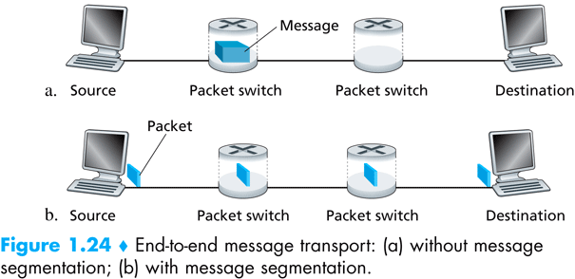

  - Assume no overhead caused by the header fields. Write a program that produces the comparison of size of each packet vs. the end-to-end delay of the transmission of the entire message of 16 kb.
Note: you may use any programing language to write your code. However, make sure all code is contained in ONE SINGLE source code file.

A screenshot of the execution of your program that displays the end-to-end delays as the size of each packet varies:

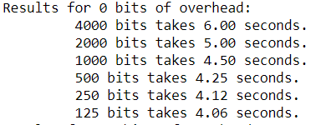

  - Assume the overhead caused by the header fields is 10 bits. Redo part a).

A screenshot of the execution of your program that displays the end-to-end delays as the size of each packet varies:

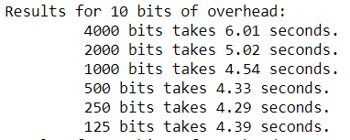
  - Assume the overhead caused by the header fields is 20 bits. Redo part a).

A screenshot of the execution of your program that displays the end-to-end delays as the size of each packet varies:

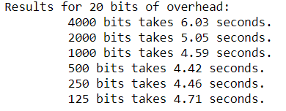
  - Plots of the results. The following two figures are what I am expecting from you.

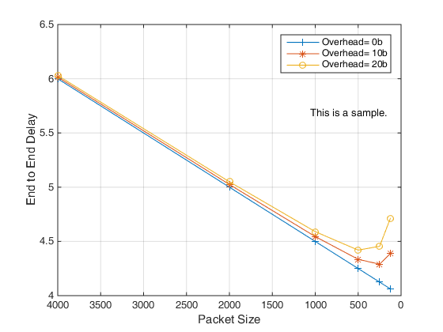

To make the plot easier to read, the packet sizes on the x axle could be scaled logarithmically.
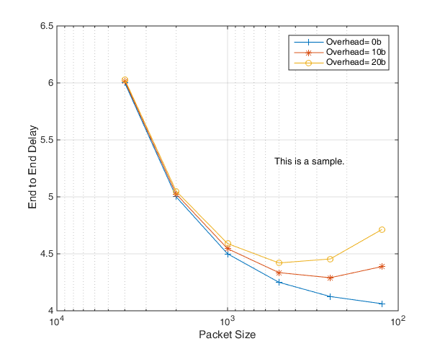

Note: you may use MS excel, MATLAB, or any tool of your choice to plot the figure.

Your two plots:
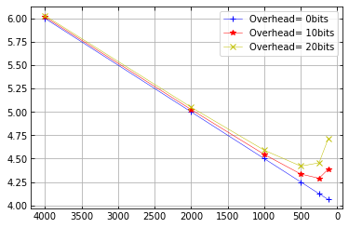
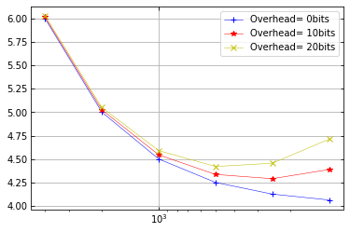
What to turn in?

- This word document with all your answers.
- The SINGLE source code file.

